LongMindStudy Software Functional Documentation
Longlong Multimodal Intelligent Study Companion
Document Type: Software features, architecture, and usage documentation
Version Date: June 15, 2026
Image Placement: Runtime screenshots are inserted beside the corresponding feature sections and scaled for reading
Font Standard: All text uses SimHei

1. Product Positioning and Learning Loop
LongMindStudy is a desktop intelligent learning application for course study, material review, and final-stage revision. It integrates material import, reading annotation, source extraction, AI-assisted reading, RAG knowledge QA, knowledge graphs, mind maps, automatic quizzes, error review, learning reports, focus and emotion recognition, music recommendation, voice control, and the Longlong companion assistant into one study workspace.
The course is the main organizational unit. Each course owns its own material library, knowledge base, graph, mind map, study plan, quizzes, error book, and report data. When the active course changes, the active material, QA context, graph structure, practice suggestions, and reflection data change with it.
The learning loop starts with materials. Users import course files, read and extract source text, learn the material into a knowledge base, ask questions through RAG, structure knowledge with graphs and mind maps, practice through quizzes, and use error records and reports to guide the next review cycle.
The desktop form connects local materials, AI services, and multimodal interaction. Users can process local PDFs and Markdown files, export edited PDF copies, control pages and materials by voice, and let camera-based state recognition, music recommendation, and reports form a continuous study record.

2. Architecture and Module Design
The project uses an Electron desktop architecture. The main process handles window creation, system file capabilities, IPC routing, AI service calls, Neo4j connections, PDF/OCR entry points, and local configuration. The preload script wraps these desktop capabilities as window.mindStudy APIs so the renderer interacts with a unified bridge instead of binding directly to system APIs.
The renderer layer consists of index.html, styles.css, app.js, vision.js, and static assets. index.html defines the page structure, styles.css provides the responsive visual system, app.js manages course data, page state, reader behavior, RAG, graphs, mind maps, quizzes, reports, voice control, and Longlong interaction, while vision.js manages camera input, multimodal recognition, and gesture control.
AI capabilities are isolated in b_qwen_module. This module includes the Qwen client, RAG index, text chunker, PDF text extraction, image-only PDF OCR, document normalization, graph generation, and QA services. The frontend calls AI through Electron-exposed APIs, which keeps model replacement and future capability expansion concentrated.
Graph capabilities use Neo4j to store concept nodes, relations, source snippets, and path-query results. Multimodal capabilities use MediaPipe models and local camera input to recognize emotion, focus, and gestures. Courses, materials, plans, knowledge bases, quizzes, reports, and Longlong state are stored in local storage and Electron user data.
Layer | Files or Services | Responsibility
Desktop shell | electron/main.js | Creates main and companion windows; handles file selection, export, AI forwarding, Neo4j, OCR, and voice IPC requests.
Security bridge | electron/preload.js | Exposes safe, limited, clearly named desktop APIs to the frontend.
Renderer UI | frontend/index.html / styles.css / app.js | Provides navigation, courses, reader, RAG, graph, mind map, quiz, report, music, and Longlong interaction.
Multimodal recognition | frontend/vision.js / MediaPipe assets | Processes camera frames, state recognition, gesture recognition, and control mapping.
AI module | b_qwen_module | Wraps Qwen, RAG, OCR, PDF extraction, graph generation, and quiz services.
Graph data | Neo4j | Persists course knowledge points, relations, source snippets, and paths.
Local persistence | localStorage / Electron userData / .local | Stores course state, keys, study timing, reports, Longlong memory, and local service configuration.

3. Beginner Guide and Main Navigation
The beginner guide is the app's entry route. During first use, Longlong introduces the left navigation and major functional areas with step cards, a yellow spotlight, progress feedback, and voice prompts. It does more than show static instructions: each step switches to the related page and highlights the relevant interaction area.
The route covers the dashboard, reader, RAG QA, Along Coding, calculator, TodoList, knowledge graph, mind map, automatic quiz, learning report, focus/music page, and Longlong chat. Users can move forward, go back, replay the current voice prompt, or close the guide.
The guide completion state is stored locally. After completion, it stays out of the way. The question-mark button near the brand area restarts it whenever users need to remember where a module is located. The voice prompts use bundled longlong-voice assets, so the fixed guidance audio can play offline.
The main interface uses a left navigation bar and a right workspace. The sidebar provides all core module entries, while the bottom course card keeps course operations visible. The top bar shows the current view title, course selector, search, voice control, camera state, and material import button.
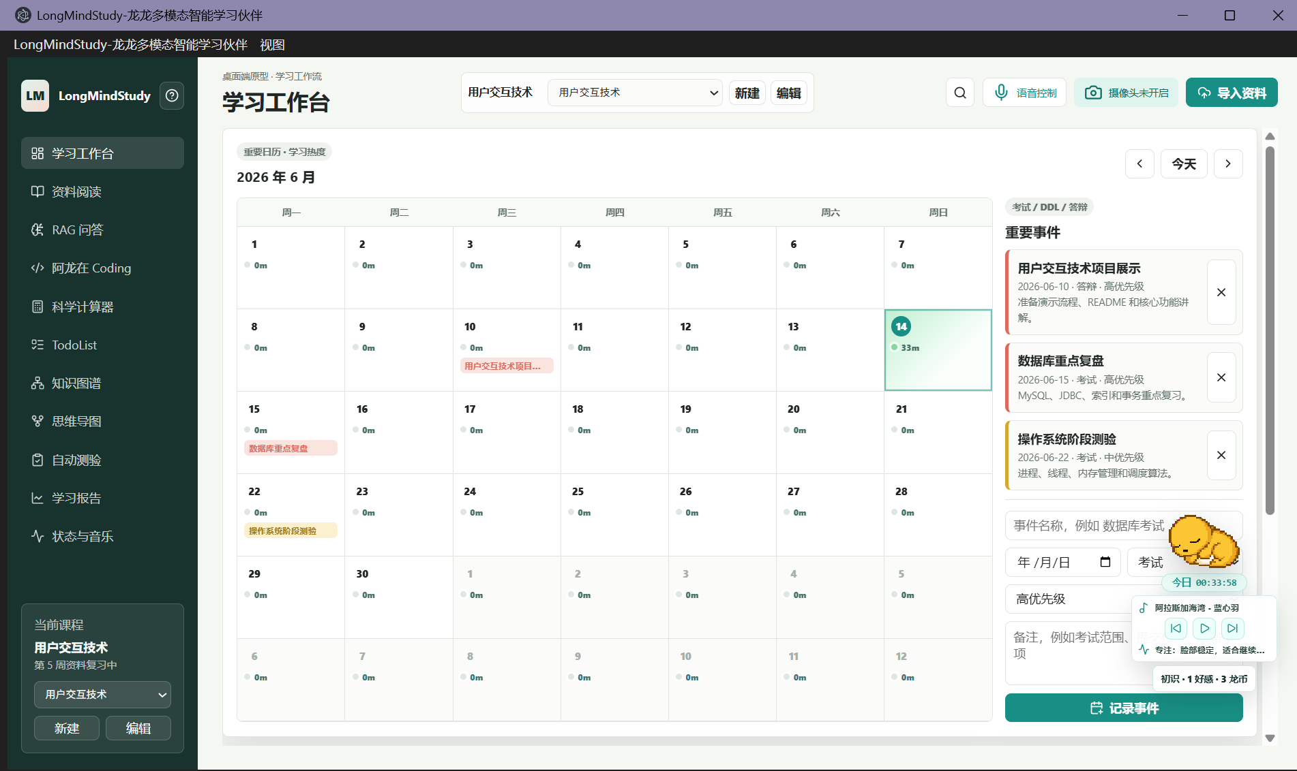
Figure 1: The dashboard shows the course calendar, study heat, events, and global navigation.

4. Courses, Material Library, and Dashboard
Course management creates, switches, and edits learning objects. A course stores its name, description, material list, active file, learning modules, RAG knowledge base, graph, mind map, quiz records, error records, reports, and reflections. This keeps multiple courses available at the same time without mixing their data.
The dashboard is the overview page. Its calendar-centered layout displays the current month, study heat, important events, and daily study duration. The event panel records exams, deadlines, defenses, interviews, and custom study items with date, type, priority, and notes.
The dashboard also provides rhythm awareness. It combines course materials, study timing, schedule events, and daily reminders so the user can decide what to study before entering deeper modules. Study-time data is synchronized with Longlong, reports, and periodic reflections.
The material library supports PDF and Markdown. Imported files are bound to the current course and can be reopened from the reader's left-side list. PDFs open in the built-in reader, and Markdown files support preview and editing. Removing a material entry changes the course library record without deleting the original local file.

5. Reader, PDF Editing, and Source Extraction
The reader uses a three-column study layout: the course material library on the left, the document reading area in the center, and intelligent assistance on the right. Pane widths are adjustable, which makes the layout usable on wide monitors, laptop screens, and fullscreen reading mode.
The PDF reader supports page navigation, page-number jumps, rendering, current-page text extraction, OCR, annotation saving, ink annotation, image insertion, blank-page insertion, current-page deletion, and export of edited PDF copies. Users can produce a new edited PDF without modifying the source file directly.
Large-file handling includes page-range operations. Users enter a start and end page to export a sub-PDF or learn only the selected range into the knowledge base. This supports large textbooks, scanned documents, and review tasks focused on a specific chapter.
Source extraction handles both text-layer PDFs and image-only PDFs. Text-layer pages are read directly; scanned pages are rendered as images and passed through OCR. Recognized text can enter AI reading, RAG learning, and knowledge QA, making image-only PDFs usable in later study modules.
The AI reading panel analyzes, summarizes, translates, and distills the current page or Markdown content. The source text and output areas can be opened in floating windows so long text is easier to copy, save, and read. Mathematical expressions are displayed in a more natural human-readable form.
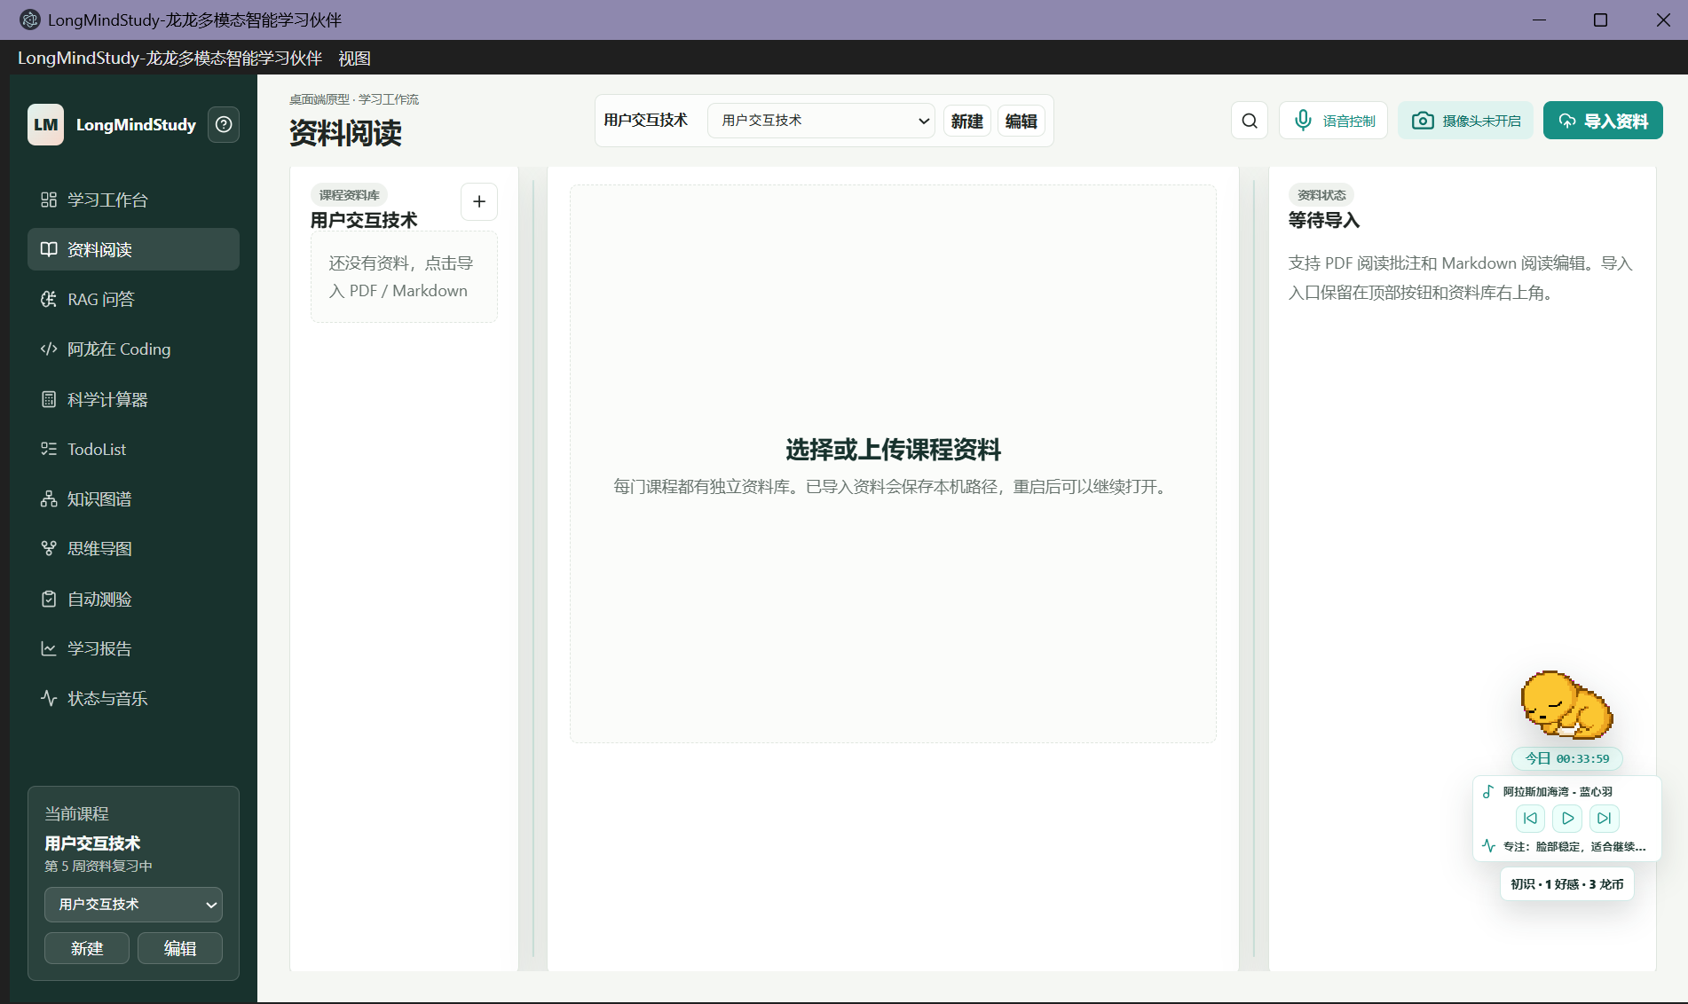
Figure 2: The reader keeps the material library, document canvas, and AI assistance in one workflow.

6. RAG Knowledge QA Assistant
The RAG page turns course materials into an answerable knowledge base. Users can learn the active file, learn the whole course, or learn a selected PDF page range. The system extracts text, runs OCR when needed, normalizes the document, splits it into knowledge chunks, and builds a local retrieval index.
The knowledge-base panel displays learned files, chunk counts, text length, OCR page counts, learning time, and page ranges. Users can clear the knowledge base or append more files to the same course. The knowledge base is course-scoped, so switching courses also switches learned files and conversation history.
When the user asks a question, the system searches the learned chunks for relevant passages and passes them to Qwen as context. Recall count and chunk length are adjustable in the UI, supporting both quick questions over small files and broader retrieval across large documents.
Web search is an optional auxiliary source. By default, answers are grounded in the local learned materials. When web search is enabled, search summaries are added as supplementary background. The UI switch lets users move between course-only QA and web-augmented QA.
The ask button becomes a stop button while an answer is being generated. Clicking it again interrupts the current request. This prevents duplicate requests caused by repeated clicks and lets users stop overly long responses. The answer area can show sources so users can trace an answer back to material snippets.
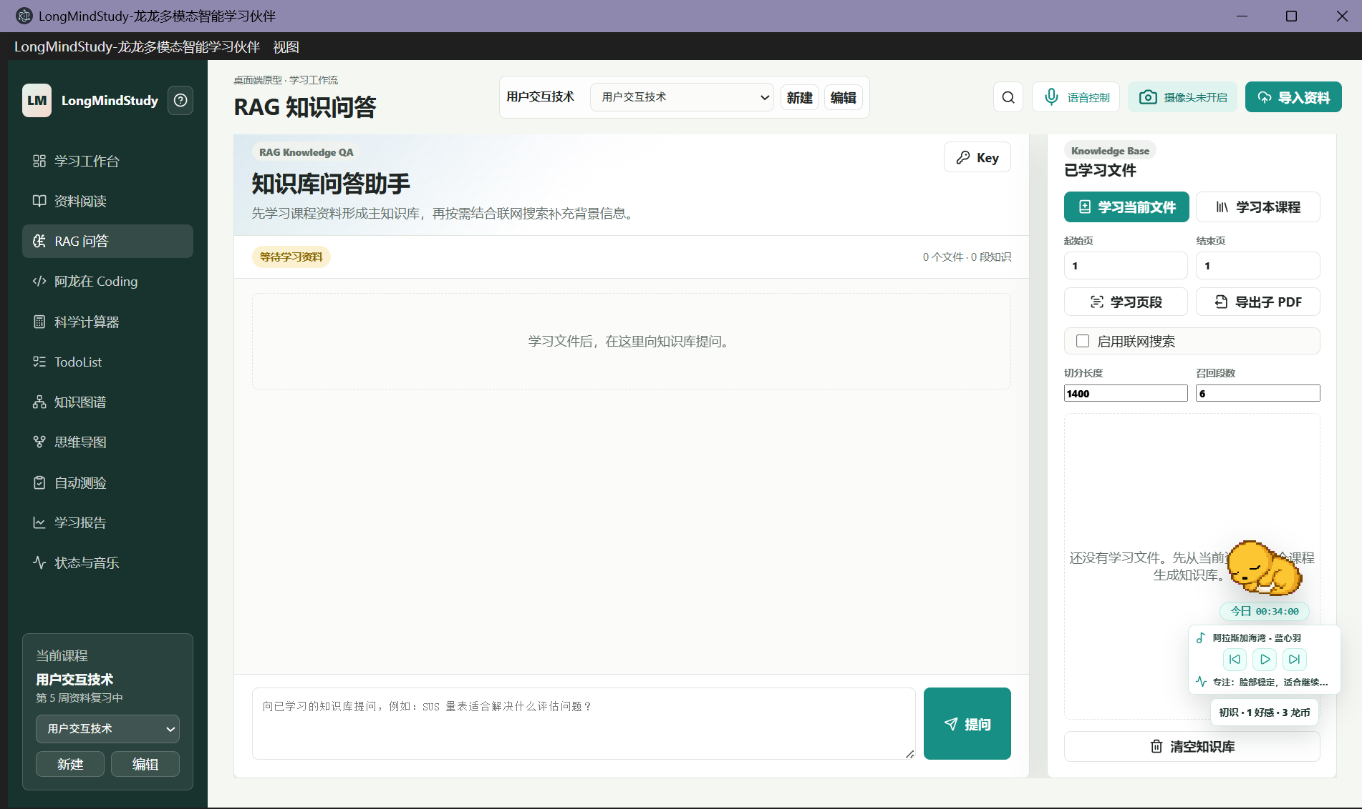
Figure 3: The RAG page provides knowledge learning, page-range learning, web-search toggle, and question entry.

7. Along Coding and Scientific Calculator
Along Coding supports programming study, algorithm practice, and code review. Users can enter only a problem statement, or enter both a problem and code. With only a problem, the assistant returns solution thinking, reference implementation direction, and complexity. With code, it analyzes feasibility, time and space complexity, boundary cases, bug risks, and optimization direction.
The page places input and analysis side by side. The left side collects language, problem, and code; the right side displays AI Code Review results. The Key button opens shared API configuration, so the coding assistant and other AI modules use the same model service settings.
The scientific calculator provides common study calculations, including arithmetic, parentheses, percentage, inverse, square, powers, factorial, square roots, trigonometric functions, inverse trigonometric functions, common logarithms, natural logarithms, scientific notation, pi, e, and Ans reuse.
DEG and RAD modes are supported for angle-sensitive calculations. The calculator is useful in HCI, statistics, graphics, physics, and other courses where temporary numerical work appears during reading or problem solving. SHIFT exposes inverse and extended functions, and keyboard input can drive calculations directly.
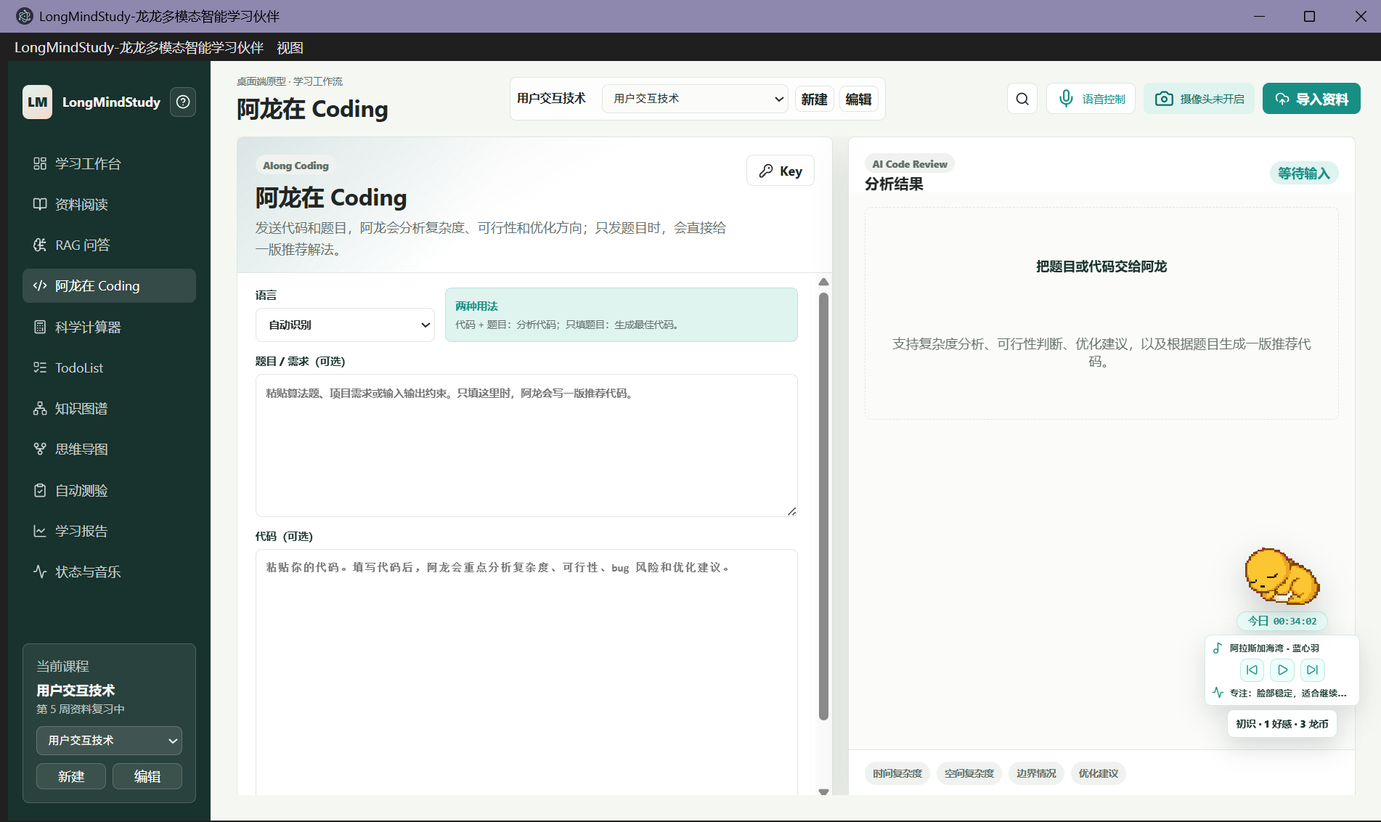
Figure 4: Along Coding supports problem, code, and requirement input with analysis results on the right.
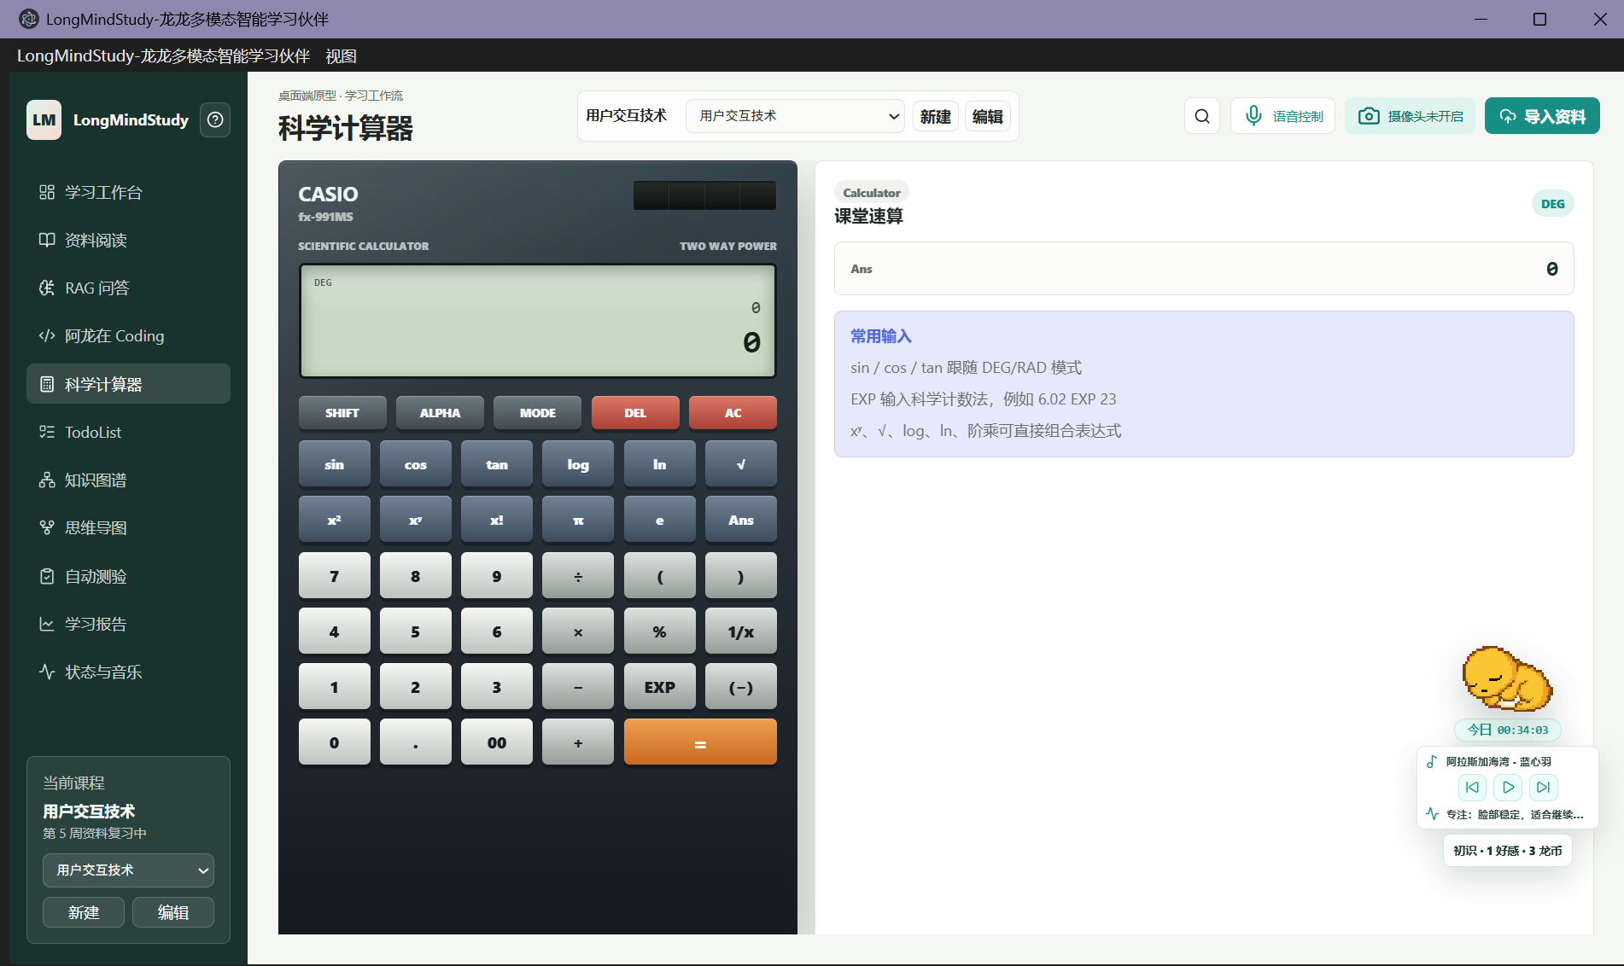
Figure 5: The scientific calculator provides common functions, angle mode, and Ans reuse.

8. TodoList, Schedule, and Study Plan
TodoList manages course review, project progress, and long-term learning tasks. Each task records type, content, status, timeline, progress, importance, and notes. Users can filter by all, in progress, not started, or completed, and the right panel lists today's queue.
Task progress is shown with sliders and percentages, and importance is shown with stars. This makes it practical to track course review, project development, coding practice, and exam preparation in one table. Task data works together with course materials and reports for long-term tracking.
The dashboard calendar and TodoList complement each other. The calendar is suited for fixed-date events such as exams and deadlines, while TodoList is suited for ongoing study tasks, stage goals, and review routes.
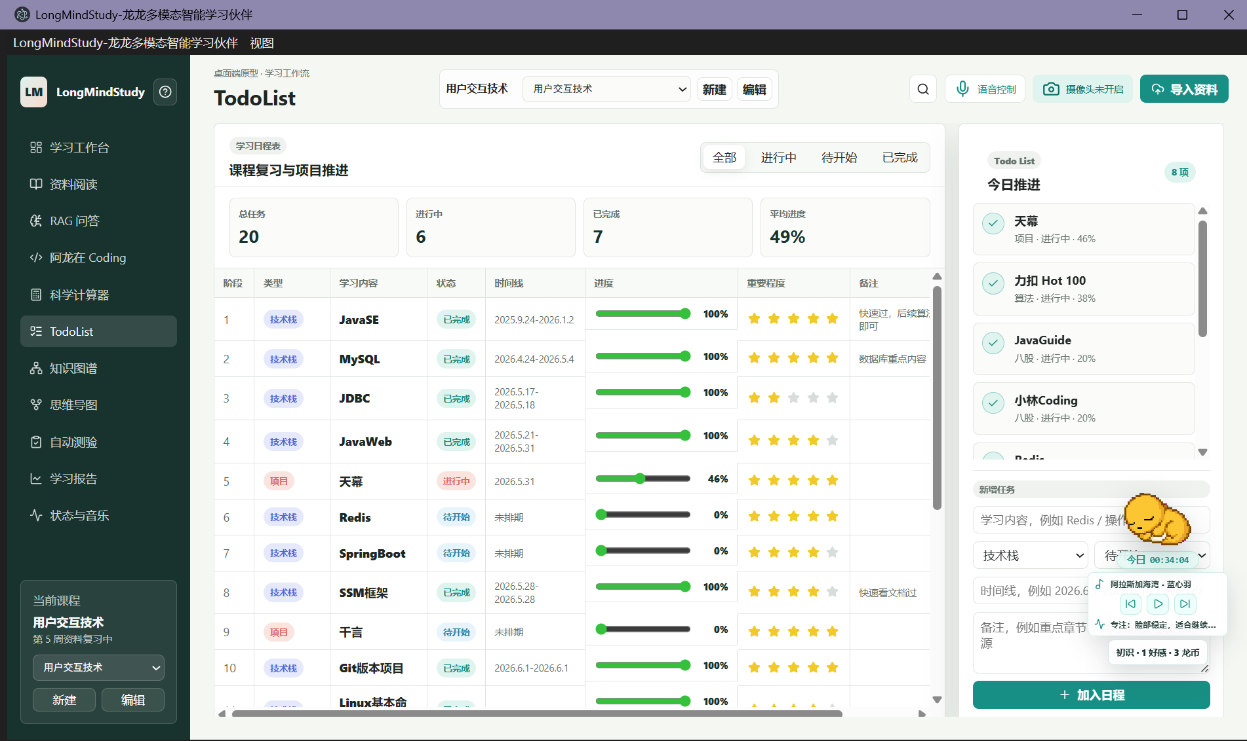
Figure 6: TodoList manages study plans through a task table and today's queue.

9. Knowledge Graph and Mind Map
The knowledge graph organizes course concepts, chapters, difficulty, mastery, source snippets, and relation paths as an interactive network. Users can generate the graph, check Neo4j connectivity, load from Neo4j, search nodes, expand neighbors, find paths, reset the view, and export Mermaid graph text.
The node detail panel shows the selected concept's summary, source, mastery, tags, and related concepts. Users can start practice from a node or inspect source snippets to understand where the concept came from. The graph is both a visualization and a review navigation tool.
The mind map starts from course topics and organizes content into hierarchical branches. It is useful before revision because it quickly exposes chapter structure and topic relationships. It supports colorful branches, compact hierarchy, chapter-based organization, difficulty-based organization, topic focus, expand/collapse, and zooming.
Mind-map nodes can be manually maintained. Users can add child topics, edit nodes, delete nodes, and adjust automatic results into a personal review map. The map can be exported as Mermaid mindmap text for reports, presentations, or further editing.
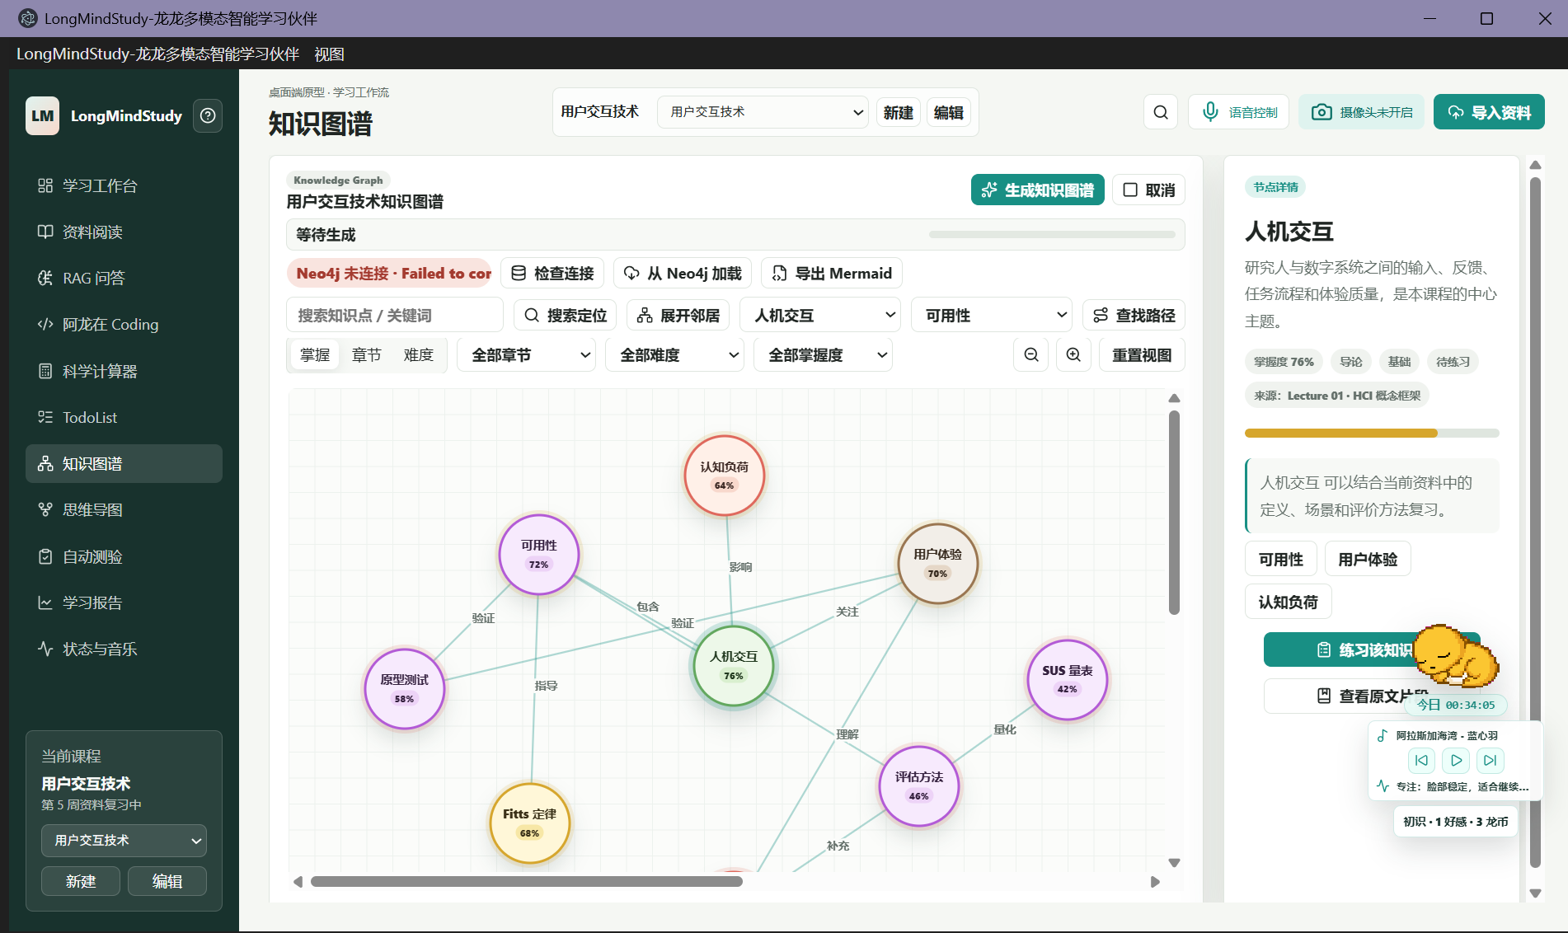
Figure 7: The knowledge graph shows concept nodes, relationships, source snippets, and graph database actions.
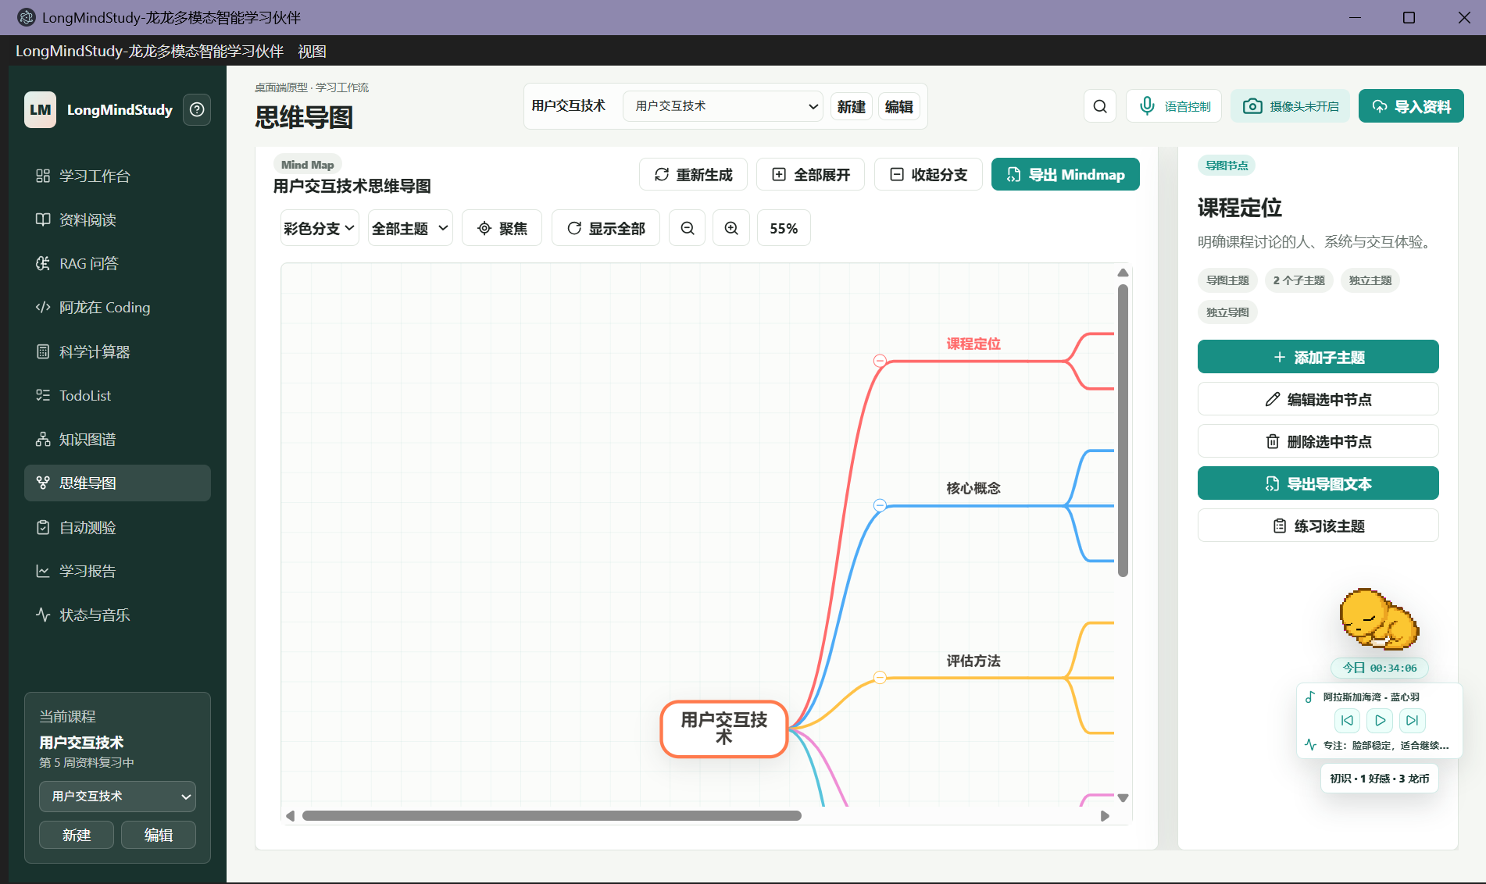
Figure 8: The mind map organizes course topics into zoomable, focusable, exportable branches.

10. Automatic Quiz, Error Book, and Learning Report
Automatic quiz converts course materials into practice sets. Users can choose adaptive practice, quick diagnosis, weak-point reinforcement, today's review, or pre-exam sprint, and configure scope, difficulty, and question counts. Supported types include single choice, multiple choice, true/false, fill-in-the-blank, short answer, and concept matching.
Objective questions are graded immediately, and the page displays correctness, correct answers, explanations, and source snippets. Short-answer questions use Qwen for semantic scoring and return scores, feedback, and missing points. Scoring results become part of the answer history and mastery statistics.
The error book automatically collects wrong answers. Each record stores the question, user answer, correct answer, explanation, source snippet, mistake reason, review level, and next review time. Users can mark items as reviewed or practice the related topic again from the report page.
The learning report summarizes course status. It shows accumulated study time, average accuracy, pending review items, seven-day learning trends, and recommended review areas. Periodic reflection can be manual, daily, or weekly, summarizing content learned, focus and emotion, material coverage, quiz accuracy, error review, and next steps since the previous reflection.
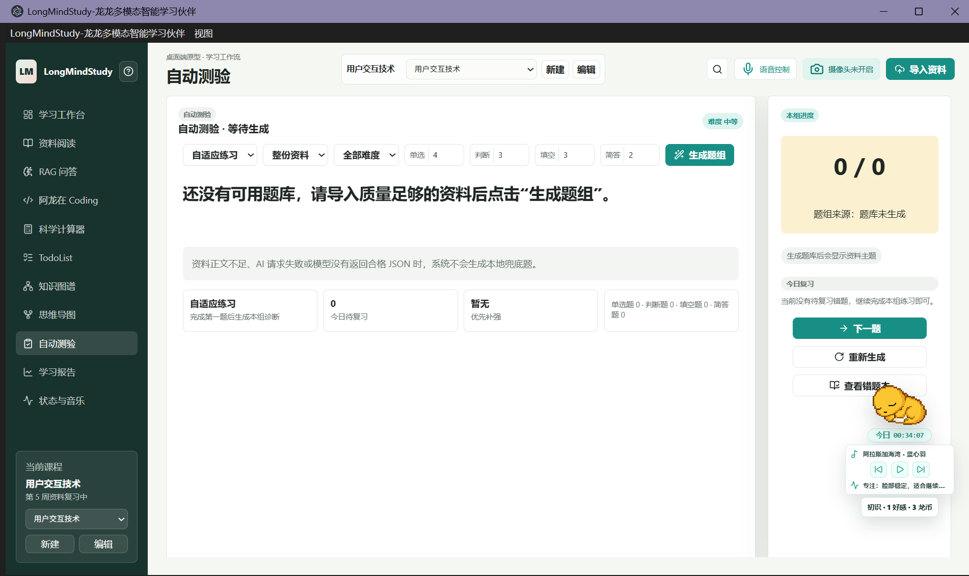
Figure 9: The automatic quiz page configures practice mode, question counts, and quiz generation.
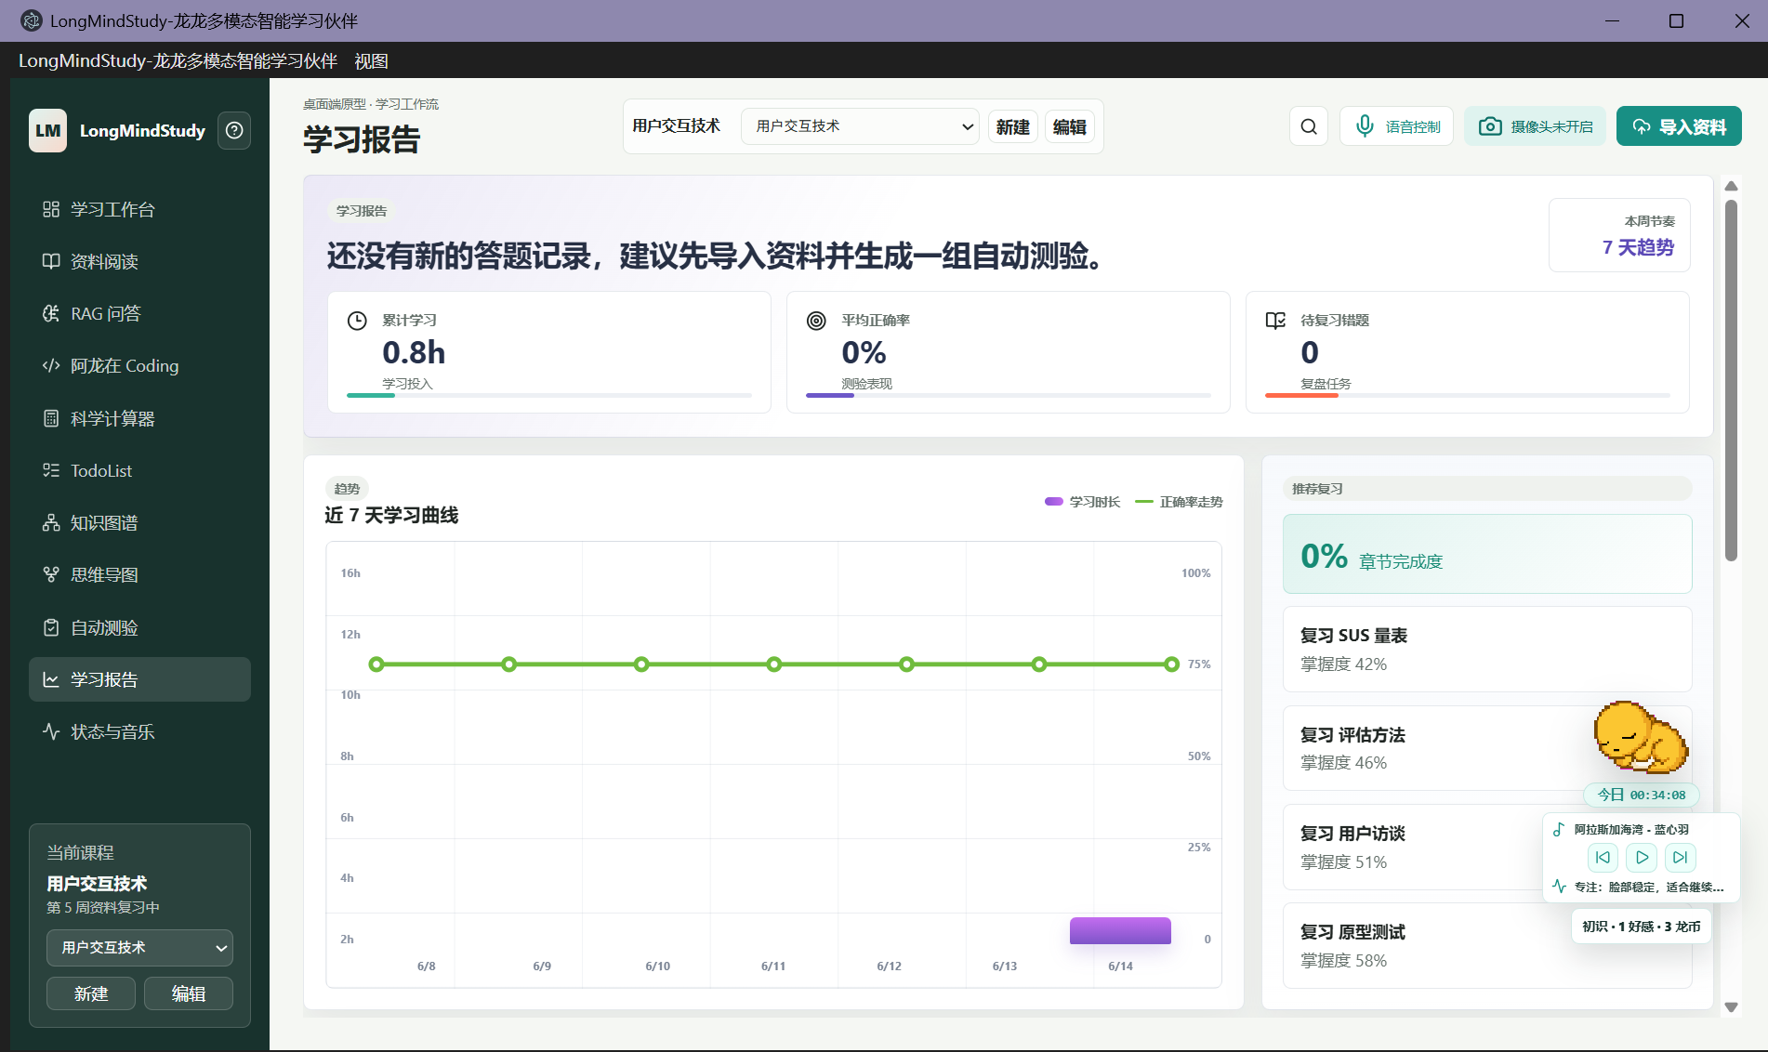
Figure 10: The learning report shows study time, accuracy, pending review, and recent trends.

11. Focus Recognition, Music Recommendation, and Voice Control
The focus and music page combines camera preview, facial-state recognition, gesture recognition, focus score, and music playback. After the user enables the camera, the app classifies focused, tired, distracted, anxious, confused, relaxed, or away states and synchronizes the result with Longlong, music recommendation, and reports.
Gesture recognition supports touch-free control inside the app. MediaPipe hand landmarks are mapped to virtual mouse movement, clicking, scrolling up, and scrolling down. Stability checks and debouncing make the gestures more suitable for reading and presentation scenarios.
Music recommendation combines current state, a fixed playlist, and playback history. Focused or relaxed states prefer stable music, while tired, anxious, confused, or distracted states shift toward softer or lower-interference tracks. The player supports play, pause, previous, next, progress dragging, volume adjustment, and local MP3 import.
Voice control is a dedicated control channel. Once enabled, the app continuously listens but responds only to executable instructions. Supported commands include page switching, importing materials, learning the current material, learning the course, generating a graph, opening previous or next material, switching by file name, turning PDF pages, jumping to a page, toggling camera state, and opening Longlong chat.
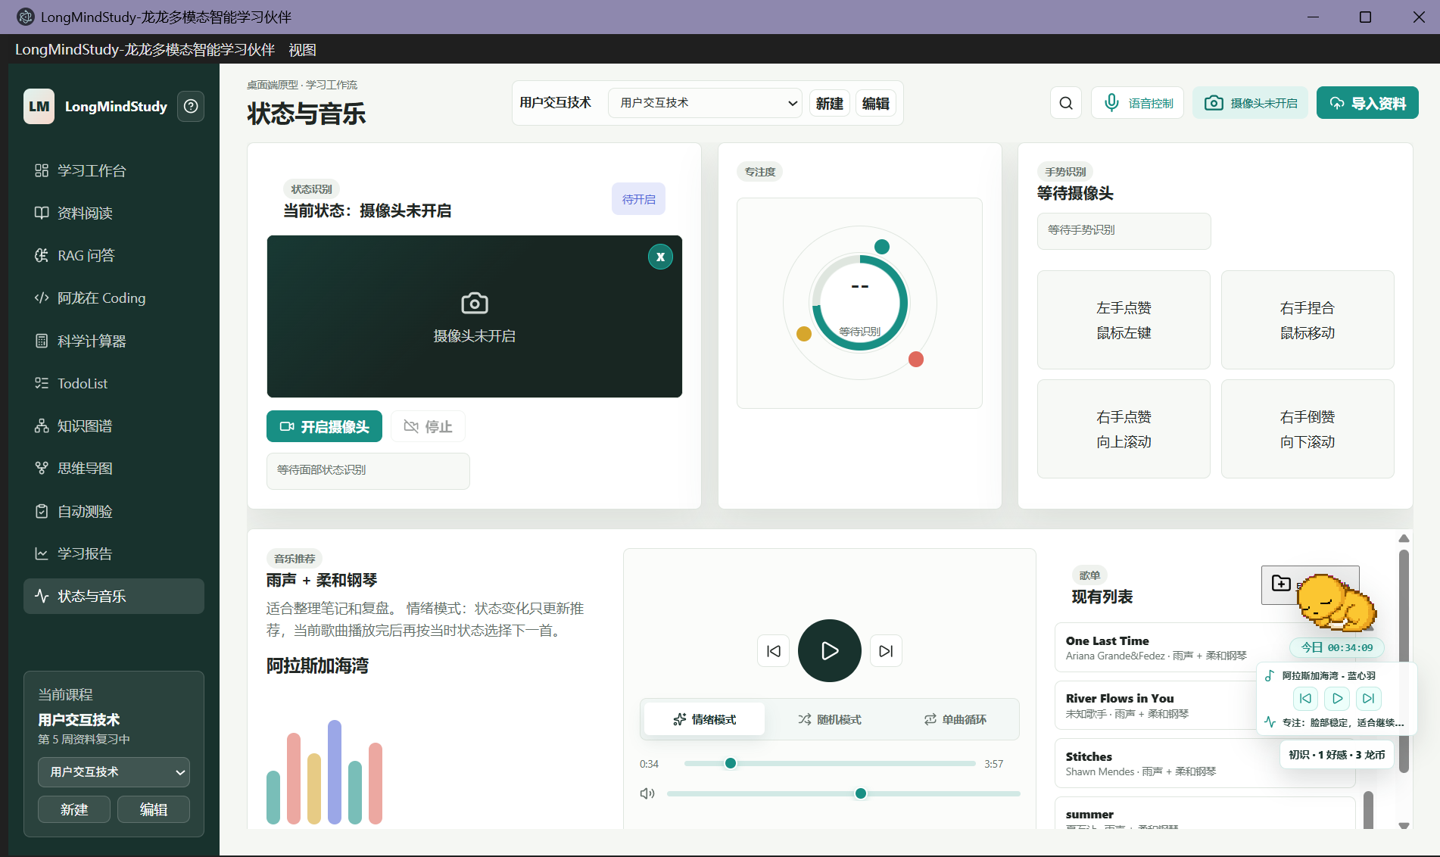
Figure 11: The focus and music page connects camera state, emotion recognition, focus feedback, and music playback.

12. Longlong Assistant, AI Configuration, and Data Storage
Longlong is the companion learning assistant. The main window keeps a Longlong status card in the lower-right area, and the desktop app can also create a separate companion window. Longlong displays today's study time, current music, current state, and short prompts, and provides chat, reminders, gifts, affection, and memory.
Longlong shares learning context with the main window. It can answer with reference to course materials, the RAG knowledge base, screen state, and recent study records. When the user asks it to remember information, it can store long-term memory. The affection system includes points, levels, coins, gifts, and owned items, and study timing contributes to coin settlement.
AI configuration uses Qwen / DashScope as the shared capability provider. Course QA, RAG, graph generation, mind-map generation, quiz generation, short-answer scoring, coding assistance, Longlong conversation, speech recognition, and multimodal input handling all call through the unified AI layer. Users can save an API Key through the in-app Key button or launch with DASHSCOPE_API_KEY / QWEN_API_KEY.
Data storage is local-first. Course libraries, material lists, RAG knowledge bases, conversation history, graph data, mind maps, quiz records, error records, reports, and plans are stored as course data. API keys, voice configuration, study timing, Longlong memory, and affection data are stored under Electron user data. Neo4j graph data stays in the local graph database, and material files come from local user paths.

13. Typical Workflow
On first use, the user follows the beginner guide, learns the major modules, and creates or selects a course. The user then imports PDF or Markdown files into the current course material library.
The material-learning workflow starts in the reader. The user selects a file, reads the source, extracts text, runs OCR, checks AI reading results, and exports a sub-PDF or learns a selected page range when needed.
Knowledge QA starts in the RAG page. The user learns the active file or the whole course and then asks questions after the knowledge base is ready. The system retrieves relevant learned chunks and generates answers with local knowledge and optional web search.
Structured review starts with the knowledge graph and mind map. The user generates a graph or map, reviews concept relations and topic hierarchy, and starts automatic quizzes from nodes or topics. Quiz results enter the error book, and the learning report converts them into review suggestions and reflections.
During long study sessions, the user can enable state recognition and music recommendation to track focus and fatigue. Voice control can remain active for material learning, page switching, and PDF navigation. Longlong continues to provide companion feedback.

12. Running and Configuration
Users install dependencies from the project root and then start the desktop application. The following commands support the usual team workflow.
- npm install: installs Electron, PDF, OCR, graph, and multimodal dependencies.
- npm start: starts the LongMindStudy desktop window.
- npm run neo4j:start: starts or connects the local Neo4j graph database.
- npm run neo4j:check: checks Neo4j connectivity.
- npm run prepare:voice: prepares fixed Longlong voice assets.
- DASHSCOPE_API_KEY / QWEN_API_KEY: provides credentials for shared Qwen capabilities.
- Music_Recommand_Key: provides independent credentials for music recommendation.

13. Overall Value
LongMindStudy turns static course files into a learning system that can be read, queried, structured, practiced, and reviewed. The reader handles input, AI reading and RAG handle understanding, graphs and mind maps handle structure, quizzes and error records handle reinforcement, reports handle reflection, and focus recognition, music, voice control, and Longlong improve the learning experience.

